Assertion
Development Guide

A suite of tools to assist with automating functional,
integration and performance testing of message based systems.

Version (Date)  Author | Description  Details
0.1.0 (2009 Oct 17)  David Gleeson | Initial Version  - OSGi packaging of Google Guava & Collections  - Message Archive & Viewer Spike

Table of Contents
Message Archive File Format 3
example.index 3
example.data 3
Message Archive Viewer 4
User Interface 4
User Stories 4
Development Environment 6
Demonstration Example 6
Depedendencies 6

Message Archive File Format

Each Archive has two files, the index which is a fixed length format and contains entries which point to a second file, the data file.

example.index
The entries are a fixed length of 128 bytes. The first enty is at byte 0 thru byte 127.
Sample Data:
[00 00 00 00 00 00 00 00] [00 00 00 0A] [00 00 01 24 60 07 77 32] [01] [02] [00 00 00 0A] [52 65 71 75 65 73 74 20 23 31 00 00 00 00 00 00 00 00 00 00 00 00 00 00 00 00 00 00 00 00 00 00 00 00 00 00 00 00 00 00 00 00 00 00 00 00 00 00 00 00 00 00 00 00 00 00 00 00 00 00 00 00 00 00 00 00 00 00 00 00 00 00 00 00 00 00 00 00 00 00 00 00 00 00 00 00 00 00 00 00 00 00 00 00 00 00 00 00 00 00 00 00]

Data (Byte Count) | Field (Data Type) | Example
[00 00 00 00 00 00 00 00] (8) | Data Position (Long) | The data file entry starts at 0
[00 00 00 0A] (4) | Data Length (Integer) | The data file entry is length 10
[00 00 01 24 60 07 77 32] (8) | Date / Time (Long / Java) | 2009-10-17 14:05:52.434
[01] (1) | Source (Byte) | This entry is from lifeline 1
[02] (1) | Target (Byte) | This entry is to lifeline 2
[00 00 00 0A] (4) | Display Name Length (Integer) | The display name is length 10.
[52 65 71 75 65 73 74 20 23 31 00 00 00 00 00 … ] (102) | Display Name (byte[])  Note: left justified right 0 pad | The display name is 'Request #1'

example.data
The entries have a position of Data Poisition and length of Data Length as defined by the fields in the .index file.

[43 6F 6E 74 65 6E 74 20 23 31]

Data (Byte Count) | Field (Data Type) | Example
[43 6F 6E 74 65 6E 74 20 23 31] (n) | Data (byte[]) | The data for entry 1 is 'Content #1' (starts at byte 0 and finishes at byte 9)

Message Archive Viewer

User Interface

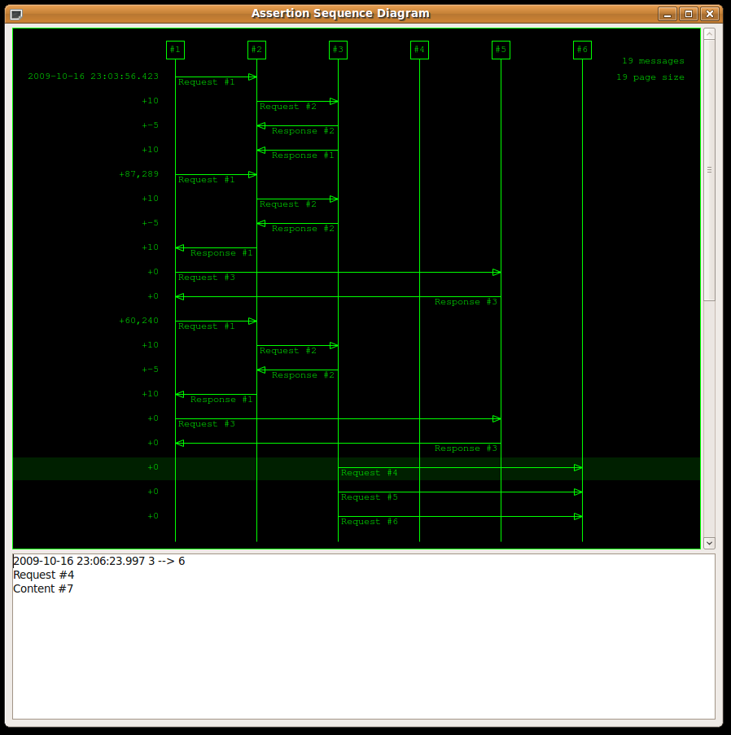

User Stories
As a user I want to view the contents of a message archive file graphically so I can explore the test execution.
- A Graphical User Interface
- A linelines for each participant in the message passing system
- Each message has a row and is active from source lifeline to target lifeline
- Pass an argument to process choose file
- Scroll bar to navigate
- Select message, highlights and can see details (including contents) in lower panel

Development Environment
Java 1.6
Eclipse Galileo 20090619-0625 with the following plugins
- For reporting on JUnit Coverage: EclEmma 1.4.2 (http://update.eclemma.org/)
Ant 1.7
Bless 0.5.2 (Hex Editor)
Open Office 3.0

Demonstration
- assertion/setup.txt
- In Eclipse:
  - ExampleArchiveThreadMain.launch
  - SequenceDiagramThreadMain - EXAMPLE.launch

Depedendencies
Title | URL
Standard Widget Toolkit User Interface Library | http://www.eclipse.org/swt
Google Guava | http://code.google.com/p/guava-libraries/
Google Collections | http://code.google.com/p/google-collections/

With infinite time and resources this would be a more formal specification.

